  



**Unlock your career potential and rise to new heights with Makkeny's expert guidance!**

**Comprehensive Documentation**

**for   
**

**Prepared by**

**Osama Zaid, Abdallah Wefky, Amr Khalid, Ahmed Mahmoud, Gehad Medhat, Shaimaa Yasser, Tasneem Emad**

**Supervised by:**

**Dr./Ramadan, Dr./Hesham**

**Faculty of Commerce, BIS Department**

**Assiut University**

**June, 2025**

**ACKNOWLEDGMENTS**

We sincerely thank our academic supervisors, Dr. Ramadan and Dr. Hesham, for their continuous guidance, insightful feedback, and unwavering support throughout this project. Their expertise and encouragement were crucial to the successful completion of our work.

We also extend our heartfelt thanks to Dr. Mostafa Qaid, Head of the Business Information Systems Department, for providing us with the necessary resources and academic environment to pursue this project.

We are grateful to the Faculty of Commerce, Assiut University, for providing the academic foundation and research facilities that made this project possible.

Finally, we acknowledge the support of our families and friends who encouraged us throughout this journey.

**Abstract**

**Makkeny** is a dynamic web-based learning platform designed to help recent graduates overcome career and skill development challenges.

It bridges the gap between academic knowledge and market needs by offering personalized learning paths, mentorship, and practical training in business, marketing, accounting, programming, and soft skills.

Built with React for the frontend, Node.js for application logic, and MongoDB for data management.

The platform features user-friendly interfaces, career guidance, tailored course recommendations, and Access to expert coaching and mentorship, reduces the time, effort, and cost associated with traditional training methods while providing more effective and targeted learning experiences.

Testing confirms Makkeny as an effective, affordable, and scalable solution for job market preparation.

**Table of Contents**

Chapter 1: Introduction 6

1.1 Purpose 6

1.2 Document Conventions 6

1.3 Intended Audience 6

1.4 Problem Statement 6

1.5 Product Scope 7

1.6 Methodology 8

Chapter 2: Software Analysis 10

2.1 Introduction 10

2.1.1 Problem Analysis and Motivation 10

2.1.2 Scope of the Project 11

2.2 System Requirements 15

2.2.1 Project Sponsor 15

2.2.2 Business Model Canvas 15

2.2.3 Business Needs 15

2.2.4 Business Request 15

2.2.5 Business Value 15

2.2.6 Specific Problem or Limitations 15

2.3 Feasibility Study 16

2.3.1 Project Definition 16

2.3.2 Market Feasibility 16

2.3.3 Technical Feasibility 16

2.3.4 Financial Feasibility 16

2.3.5 Risk Assessment 16

Chapter 3: System Architecture and Design Models 17

3.1 Architectural Design 17

3.2 Diagrams Description: ERD, UML, etc…... 21

3.3Interface Design 22

3.3.1 Overview of User Interface 22

3.3.2 Screen Images 25

Chapter 4: Software Requirements Specifications 31

4.1 Overall Description 31

4.1.1 Product Perspective 31

4.1.2 Product Functions 31

4.1.3 User Classes and Characteristics 31

4.1.4 Operating Environment 31

4.1.5 Design and Implementation Constraints 31

4.1.6 User Documentation 31

4.1.7 Assumptions and Dependencies 31

4.2 External Interface Requirements 31

4.2.1 User Interfaces 31

4.2.2 Hardware Interfaces 31

4.2.3 Software Interfaces 31

4.2.4 Communications Interfaces 31

4.3 System Features (Functional Requirements) 32

4.3.1 User Management System 32

4.3.2 Course and Content Management 32

4.3.3 Career Development Services 32

4.3.4 Administrative Functions 32

4.3.5 Personalized Learning Paths 32

4.3.6 Mentoring Management System 32

4.3.7 Feedback and Improvement System 32

4.4 Other Nonfunctional Requirements 32

4.4.1 Performance Requirements 32

4.4.2 Security Requirements 32

4.4.3 Software Quality Attributes 32

4.4.4 Business Rules 32

4.4.5 Culture and political 32

Conclusion 33

Future Works 34

Appendices 35

Appendix A: Professional Considerations 35

Appendix B: Glossary / Acronyms 37

Appendix C: To Be Determined List 37

References 38

# Chapter 1: Introduction

## 1.1 Purpose

Makkeny is a web application designed to assist recent graduates, particularly from the Faculty of Commerce at Assiut University, in navigating the labor market. The application aims to provide a secure and user-friendly platform for career development and skill enhancement by offering targeted course recommendations, personalized career counseling, mentorship, and practical experience opportunities. The purpose of this document is to outline the software requirements for the Makkeny application to ensure it meets the needs of its users while maintaining security and usability.

## 1.2 Document Conventions

1. Register a new account for users (Users, Instructors, Mentors, Admins).
2. Allow users to browse and enroll in courses.
3. Facilitate career counseling sessions and mentorship programs.
4. Enable users to apply for internships and workshops.
5. Provide admin functionalities to manage users, courses, and events

## 1.3 Intended Audience

1. **Developers**: Responsible for implementing the application.
2. **Project Managers**: Oversee the project timeline and resources.
3. **Marketing Staff**: Promote the application to target users.
4. **Users**: Users, mentors, admins, and Instructors.
5. **Testers**: Ensure the application meets quality standards.
6. **Documentation Writers**: Create user manuals and help files.

## 1.4 Problem Statement

Recent graduates, particularly from the Faculty of Commerce at Assiut University, face significant challenges in transitioning from academic environments to professional careers. The current job market presents several critical obstacles that hinder successful career development:

**Skills Gap Challenge**: Many graduates possess theoretical knowledge but lack the practical skills and industry-specific competencies that employers actively seek. Traditional academic curricula often fail to keep pace with rapidly evolving industry requirements, leaving graduates inadequately prepared for modern workplace demands.

**Limited Career Guidance**: Most graduates lack access to personalized career counseling and professional guidance during the critical transition period following graduation. Without proper direction, many graduates make uninformed career decisions or remain unemployed for extended periods.

**Networking Limitations**: Recent graduates typically have limited professional networks and lack connections with industry professionals who could provide mentorship, advice, or employment opportunities. This isolation significantly impacts their ability to discover and pursue suitable career paths.

**Information Accessibility**: Current resources for career development, skill enhancement, and professional training are often fragmented, expensive, or difficult to access. Graduates struggle to find consolidated platforms that address their diverse professional development needs.

**Market Mismatch**: There exists a disconnect between graduate capabilities and employer expectations, resulting in high unemployment rates among recent graduates and prolonged hiring processes for employers seeking qualified candidates.

These challenges collectively create a barrier to successful career development, necessitating a comprehensive solution that addresses multiple aspects of professional preparation and career transition.

## 1.5 Product Scope

**Objective**:

Makkeny aims to help recent graduates find suitable career paths by providing access to industry relevant training and opportunities at affordable costs.

**Goals**:

* Facilitate skill enhancement through tailored courses and workshops.
* Provide personalized career counseling and mentorship.
* Offer practical experience via internships with partnered companies.

**Benefits**:

* Graduates gain access to affordable, targeted training.
* Companies can connect with potential talent.
* The platform earns a commission from course enrollments and partnerships

## 1.6 Methodology

The development of the **Makkeny** web application will follow the **Agile Software Development Life Cycle (SDLC)** methodology. Agile was selected due to its flexibility, iterative nature, and strong focus on collaboration and user feedback. This approach ensures that the system evolves based on continuous stakeholder involvement and changing user requirements.

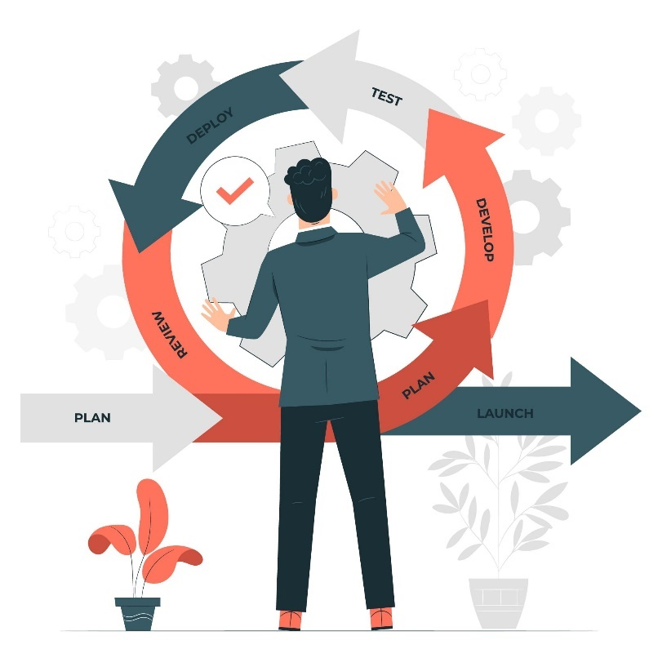

**Key Steps:**

1. **Requirement Gathering:**  
   Conduct interviews, surveys, and focus groups with stakeholders including students, mentors, and instructors to collect functional and non-functional requirements.
2. **Planning:**  
   Break down the project into smaller sprints, define timelines, assign tasks, and prepare for iteration planning meetings.
3. **Design:**  
   Create wireframes, user interface designs (supporting both dark and light modes), and system architecture including ERD, UML, and user stories.
4. **Development:**  
   Use modern web technologies such as **.NET Core (backend)** and **React.js (frontend)** to implement features like registration, course browsing, mentorship matching, and admin dashboards.
5. **Testing:**  
   Implement unit testing, integration testing, and user acceptance testing (UAT) to ensure quality and security standards are met.
6. **Deployment:**  
   Host the application on a cloud server with SSL for security and ensure scalability for future expansion.
7. **Maintenance and Updates:**  
   Continue improving the system post-launch through user feedback and feature enhancements in future sprints.

# Chapter 2: Software Analysis

## 2.1 Introduction

System analysis represents a critical phase in the development of the Makkeny web application, providing the foundation for understanding the complex requirements, constraints, and opportunities that shape the project's direction.

This chapter presents an in-depth analysis of the challenges faced by recent graduates and how the Makkeny system addresses these problems. It highlights the core motivations behind the platform's development and outlines its overall scope and impact on the target audience.

### 2.1.1 Problem Analysis and Motivation

Recent graduates, especially those from the Faculty of Commerce, often face several challenges entering the labor market, such as:

* **Lack of practical experience** and job-readiness skills.
* **Limited access** to career counseling or mentorship programs.
* **Difficulty in finding relevant training opportunities** tailored to their field.
* **Fragmented platforms** for internships, workshops, and soft skills development.

These challenges lead to a gap between academic knowledge and job market requirements, resulting in underemployment or misaligned career paths.

**Motivation:**  
The motivation behind Makkeny is to create an integrated, easy-to-use platform that helps bridge the gap between education and employment by offering:

* Personalized learning paths.
* Access to real industry mentorship.
* Opportunities for internships and workshops.
* A central hub for career growth tailored to Egyptian graduates.

### 2.1.2 Scope of the Project

**Product Scope Description**

Develop a dynamic website to bridge the gap between academic education and job market demands for recent graduates in Egypt, focusing on commerce, IT, and skill development (e.g., soft skills, technical training)

**Users Covered:**

* **Graduates/Students**: To register, learn, get mentored, and apply for opportunities.
* **Instructors**: To publish and manage courses.
* **Mentors**: To provide guidance and career advice.
* **Admins**: To monitor, approve content, and manage system activities.

**Main Features:**

* registration and authentication
* Personalized career recommendations
* Access to expert coaching and mentorship
* Tailored Course Recommendations
* Course browsing and enrollment
* Admin dashboard for managing content and users
* AI-powered chatbot for customer support

**Product Acceptance Criteria**

The project will be considered complete and successful if:

* All features listed in the product scope are developed and fully functional
* The platform runs smoothly on major modern browsers without critical bugs
* Career recommendation algorithms operate accurately based on user profiles
* Admins can manage content and monitor user analytics effectively
* The system complies with data privacy and security standards

**Project Deliverables**

In addition to the Makkeny web platform, the project will deliver:

* Platform Website.
* System design and architecture documents.
* Expert Career Coaching & Mentorship: Connect students with professionals for guidance

and support.

* AI-Powered Career Recommendations: Suggest career options based on student profiles

and market demand.

* customer support chat-bot.
* Admin dashboard.
* Documentation.

**Project Exclusions (Out of Scope)**

* Development of native mobile applications (web-only platform)
* Integration with external hiring or internship portals (after a period of release)
* Full accreditation or certification for courses (handled externally)
* Post-launch analytics dashboards (may be in next release)
* Offline Functionality: Limited offline access (requires internet).
* Advanced AI or deep-learning models (basic AI functionality only)

**Project Constraints**

* **Time**: The project must be delivered before the end of June, with testing and launch in the final month
* **Budget**: The budget is capped at 360,000 EGP
* **Technology**: Must use React for frontend and Node.js for backend
* **Hosting**: Cloud-based hosting is required
* **Resources**: Limited to the current internal development team

**Project Assumptions**

* Mentors and consultants will be available to contribute content and guidance
* The university supports and promotes the platform among students
* Users have access to stable internet
* The Platform will require access to third-party APIs (e.g., payment gateways), and it is

assumed these APIs will be fully operational throughout the project.

* Admin users will be available to test and provide feedback during pilot phase

## 2.2 System Requirements

### Project Sponsor

### Business Model Canvas

### Business Needs

### Business Request

### Business Value

### Specific Problem or Limitations

## 2.3 Feasibility Study

### 2.3.1 Project Definition

* **Objective**: What problem does the project solve?
* **Scope**: Products/services offered.
* **Key Stakeholders:** Who is involved?

### 2.3.2 Market Feasibility

* **Target Audience:** Demographics, needs, and preferences.
* **Competitor Analysis (SWOT analysis):** (Strengths, Weaknesses, Opportunities, Threats).
* **Market Size & Demand:** Is there enough demand?
* **Surveys/Feedback:** Customer opinions (if applicable).

### 2.3.3 Technical Feasibility

* **Resources Needed:** Equipment, technology, workforce.
* **Technology Availability:** Can it be implemented?
* **Location & Logistics:** Is the site suitable?
* **Timeline:** Estimated project phases.

### 2.3.4 Financial Feasibility

* **Estimated Costs:** Startup, operational, and maintenance costs.
* **Funding Sources:** Loans, investors, self-funding.
* **Revenue Projections:** Sales forecasts, break-even analysis.
* **Profitability Metrics:** ROI, NPV, Payback Period.

### 2.3.5 Risk Assessment

* **Potential Risks:** Market shifts, competition, operational challenges.
* **Mitigation Strategies:** How to minimize risks?

# Chapter 3: System Architecture and Design Models

## 3.1 Architectural Design

The system is composed of several core components, each representing a specific layer or function within the architecture:

* **User Interface Module**:

Responsible for handling user interactions. Includes components for user registration, request submission, and point tracking. Interfaces with the Business Logic module for processing user requests.

* **Business Logic Module**:

Manages the core functionalities of the application. Validates user requests and matches them with appropriate service providers. Calculates points and discounts for users. Interfaces with the Data Access module for accessing and updating data.

* **Service Provider Module**:

Handles activities related to service providers. Allows service providers to add, edit, and delete services offered. Interfaces with the Business Logic module for service request processing.

* **Data Access Module**:

Manages access to the data repositories. Handles CRUD operations for user accounts, service requests, and service provider information. Ensures data security and integrity.

* **Communication Module**:

Facilitates communication between users and service providers. Handles notifications, messages, and updates. Interfaces with both the User Interface and Business Logic modules.

Figure 1 System **Architectural Design**

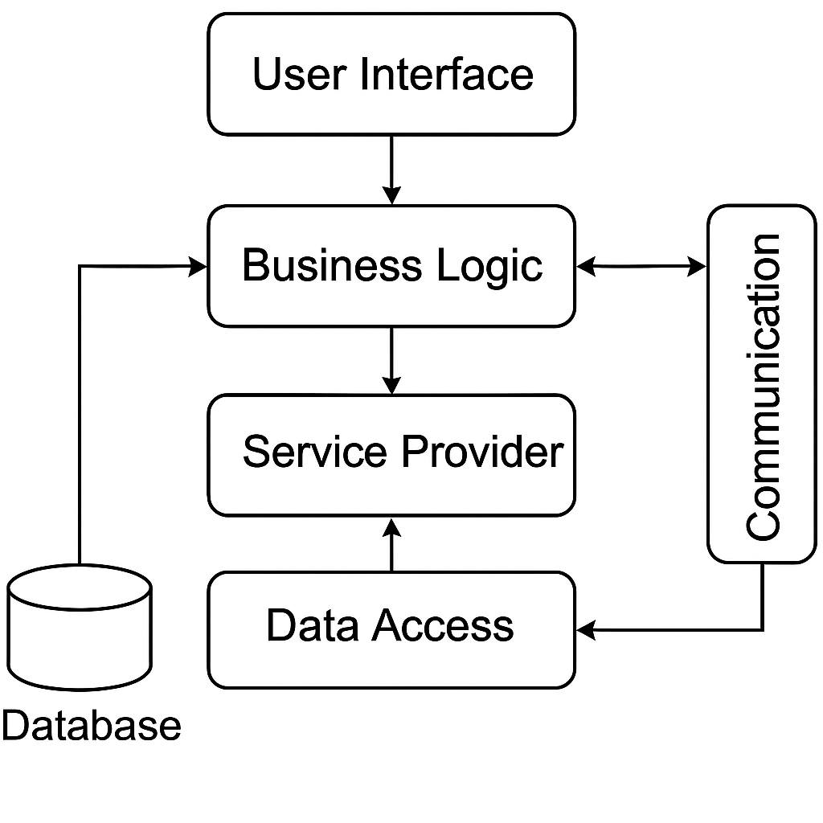

**Description of the Diagram:**

The diagram illustrates the major subsystems: User Interface, Business Logic, Service Provider, Data Access, and Communication.

Arrows indicate the flow of information between subsystems.

User Interface interacts with Business Logic for request processing and Data Access for user information.

Service Provider communicates with Business Logic for service management.

Data Access manages access to the database, ensuring data integrity.

Communication facilitates interaction between users and service providers.

This architecture promotes modularity and separation of concerns, allowing for easier maintenance, scalability, and collaboration between subsystems to achieve the desired functionality of the system.

Figure 2 Example

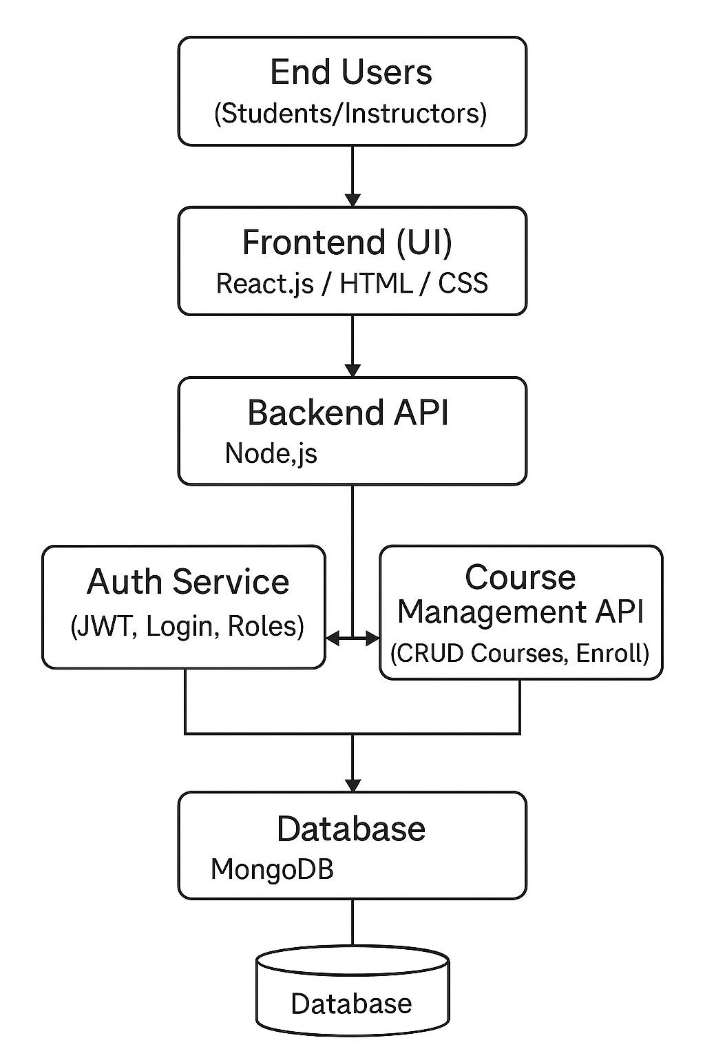

**End Users:**

Represent the external actors of the system, including students, instructors, and administrators. Interact with the system via the User Interface Module to perform various actions such as registration, course enrollment, and system management.

**Frontend (UI):**

Corresponds to the User Interface Module. Responsible for handling user interactions such as registration, login, navigation, and request submission. Provides a user-friendly interface and connects directly to the Business Logic module for processing operations.

**Backend API:**

Represents the Business Logic Module. Handles the core functionalities of the application including request validation, course and user management, and coordination between services. Interfaces with the Data Access module for reading/writing data and with the Auth Service for user authentication and access control.

**Auth Service:**

A sub-module of the Business Logic or a dedicated microservice. Manages user authentication, authorization, and role-based access control. Ensures secure access to protected resources in the system.

**Course Management API:**

Represents the Service Provider Module. Allows instructors to create, update, and manage their courses. Enables linking of course content with enrolled users and integrates with the Business Logic for validation and tracking.

**Database:**

Corresponds to the Data Access Module. Manages CRUD operations for users, courses, sessions, and system logs. Ensures data consistency, security, and integrity across the platform.

## 3.2 Diagrams Description: ERD, UML, etc…...

## 3.3Interface Design

### 3.3.1 Overview of User Interface

The user interface (UI) of the Makkeny System is designed with user experience as the primary focus, providing a clean, intuitive, and accessible interface that caters to diverse user needs. The interface emphasizes simplicity and functionality, ensuring users can navigate effortlessly through various features and complete tasks efficiently. To enhance user comfort and accessibility, the application supports both dark and light modes, allowing users to choose their preferred visual theme based on personal preference or environmental conditions.

**The following is a high-level overview of the Makkeny UI**

* **Home Screen**

The home screen serves as the primary landing page and navigation hub for the application. It features a mobile-responsive design with clean typography and intuitive navigation elements. The interface provides quick access to core functionalities while maintaining a welcoming and professional appearance that sets the tone for the user experience.

* **Registration Page**

The registration interface allows new users to create accounts through a streamlined signup process. The form is designed with clear input fields, validation messages, and user-friendly prompts that guide users through account creation. The layout prioritizes clarity and reduces form complexity to minimize user friction during the signup process.

* **Email Verification**

A dedicated verification screen that appears after user registration, providing clear instructions for email confirmation. This interface maintains consistency with the overall design language while clearly communicating the next steps required to activate the user account.

* **Login Page**

The authentication interface provides secure user access through a clean, focused design. The login form features standard email and password fields with clear labeling, error handling, and additional options for account recovery. The design emphasizes security while maintaining ease of use.

* **Password Recovery System**
* **Forget Password**

A dedicated interface for users who need to reset their passwords. The screen provides a simple form where users can enter their email address to initiate the password recovery process, with clear instructions and helpful messaging.

* **OTP Verification**

The one-time password (OTP) verification screen appears during the password reset process, allowing users to enter the verification code sent to their email. The interface is designed to clearly display the input field and provide guidance on where to find the verification code.

* **Reset Password**

The final step in the password recovery process, featuring a secure form where users can create a new password. The interface includes password strength indicators and confirmation fields to ensure users create secure, matching passwords.

* **Admin Dashboard**

The administrative interface is designed as a comprehensive control panel providing system administrators with complete oversight and management capabilities through several key components:

**Header and Navigation:**

* Features a prominent logout button in the top-left corner
* Clean header design with the main title prominently displayed in teal coloring

**Statistics Overview Cards:**

The dashboard displays key metrics through a series of informative cards showing:

* Published Courses
* Suspended Courses
* Mentors
* Instructors
* Students
* Total Visitors

**Navigation Tabs:**

Four main functional tabs provide access to different administrative sections:

* General Overview: Welcome message explaining platform management capabilities through the sections above
* Courses: Displays Courses and Shows Suspended Course Section
* Instructors: Add new Instructor with Email
* Classifications: Add Classification with description

**General Overview:**

The dashboard maintains consistency in design with rounded cards, appropriate spacing, and a professional color scheme using teal accents and clean typography.

### 3.3.2 Screen Images

**Home Screen**

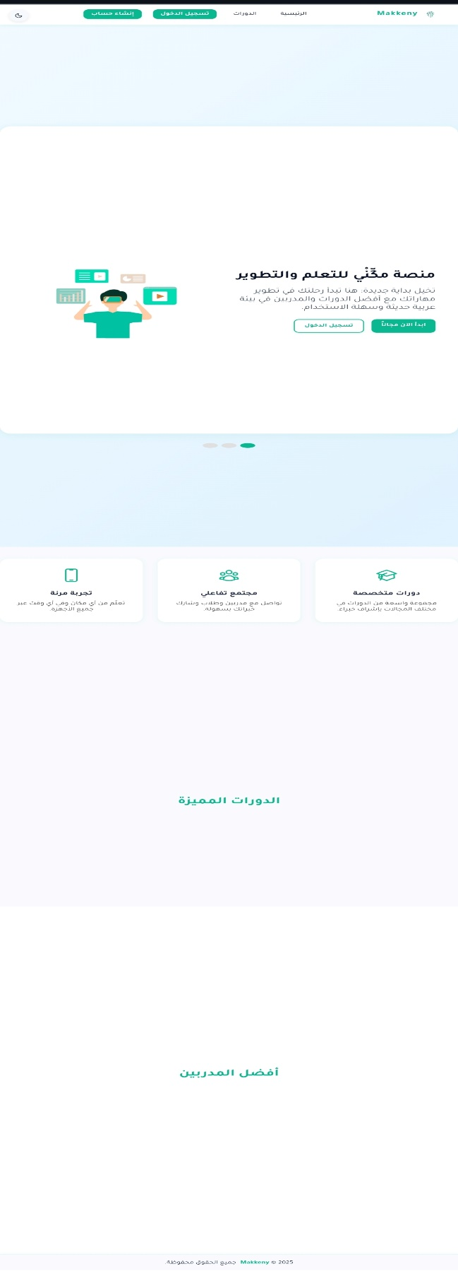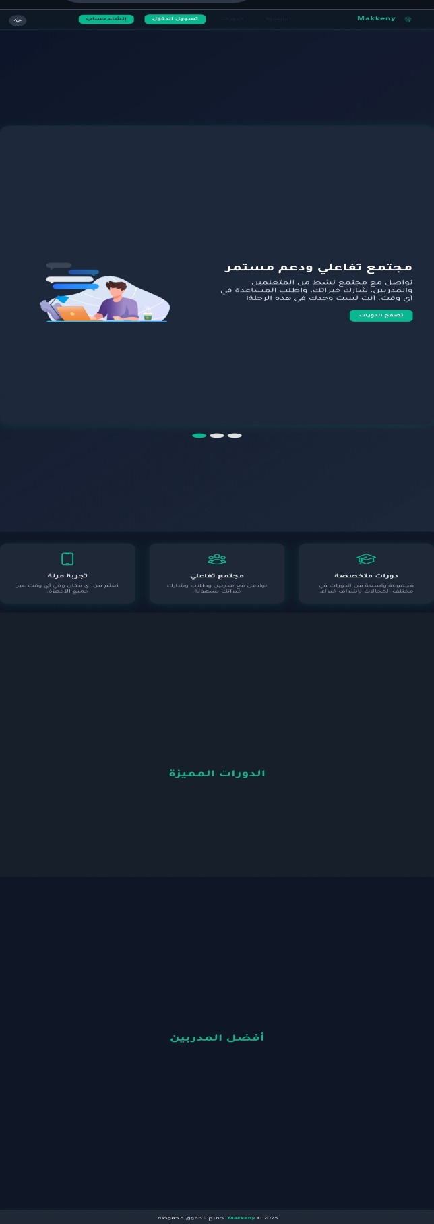

**Register page**

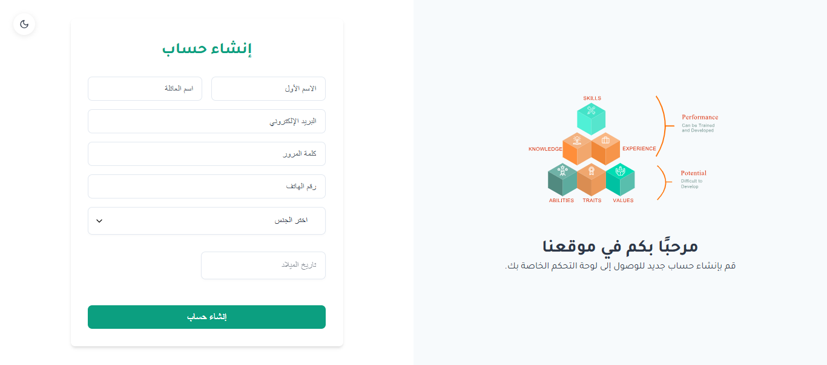

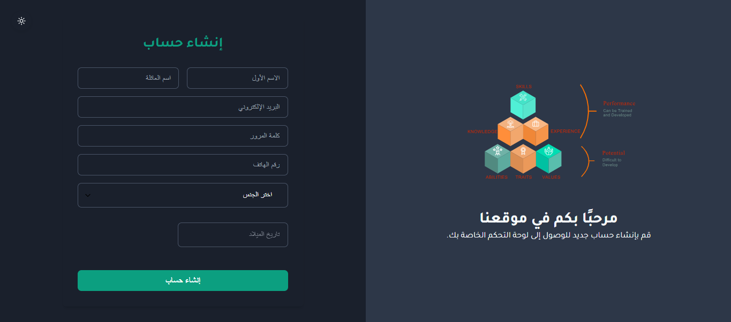

**Verify Email**

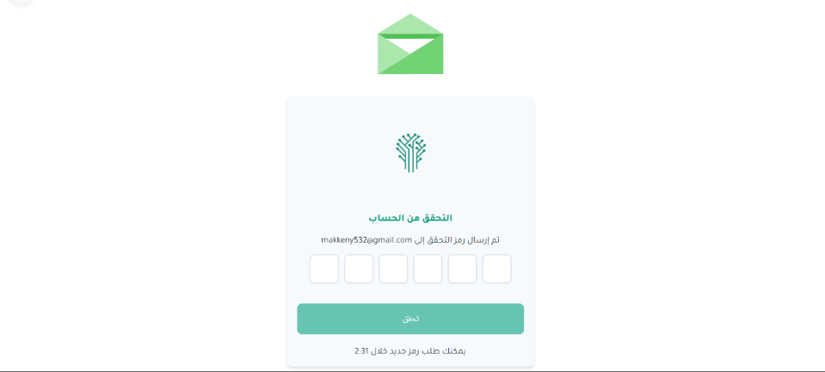

**Login page**

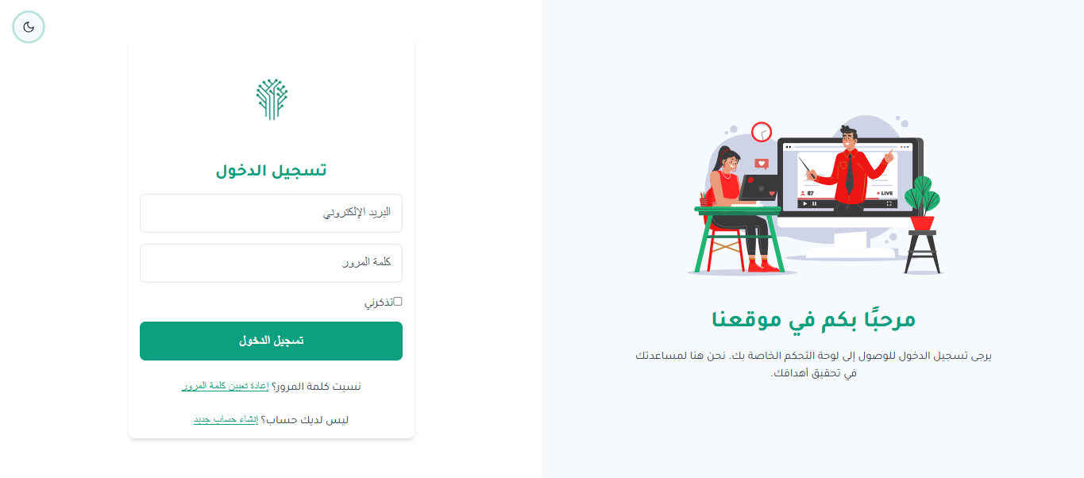

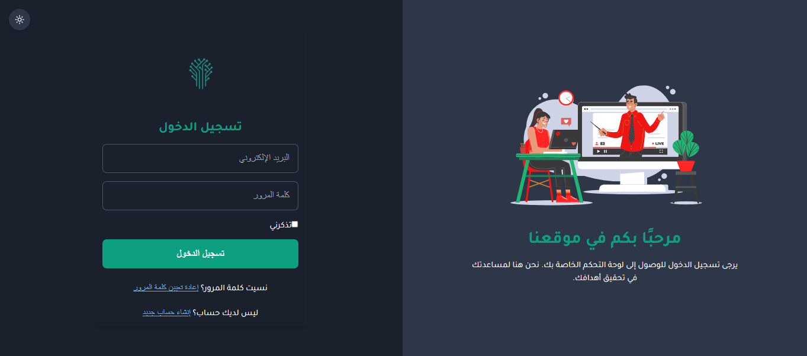

**Forget Password**

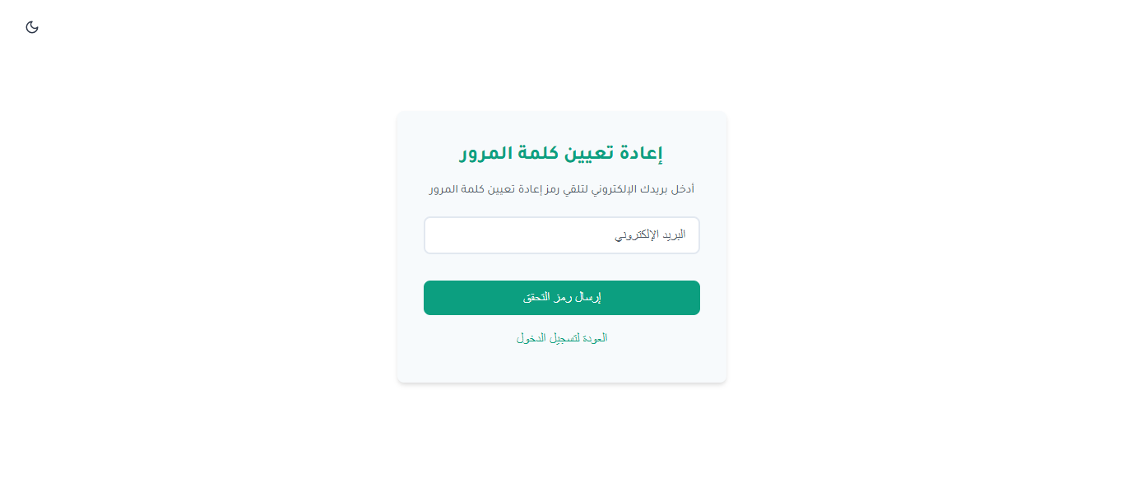  
**OTP to reset password**

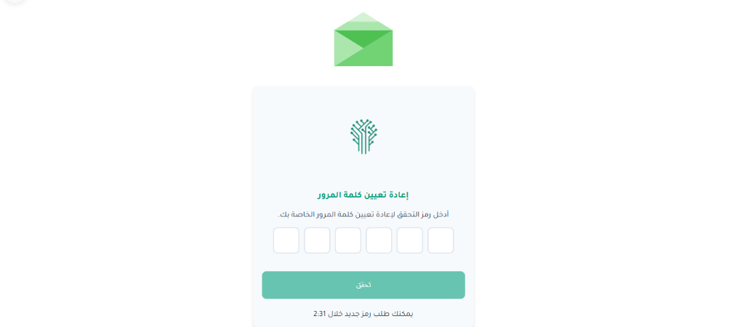

**Reset Password**

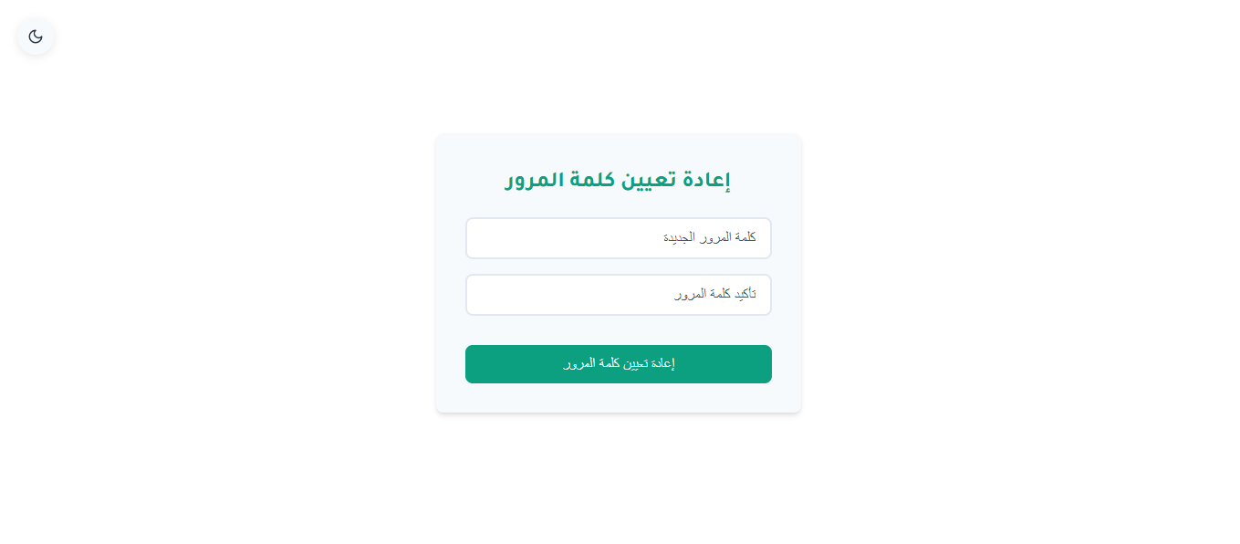

**Admin Dashboard**

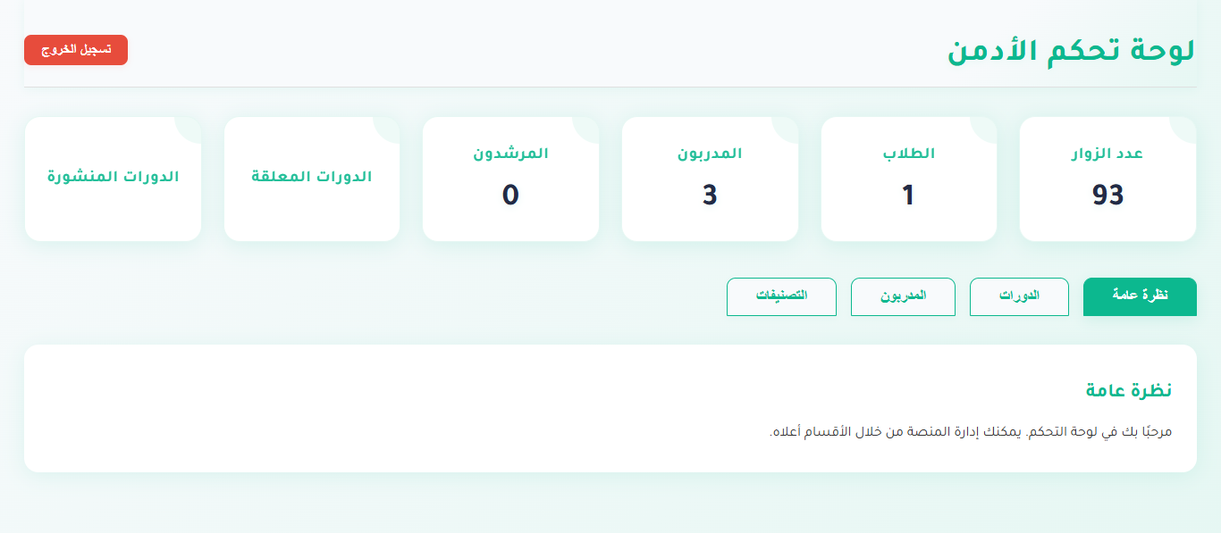

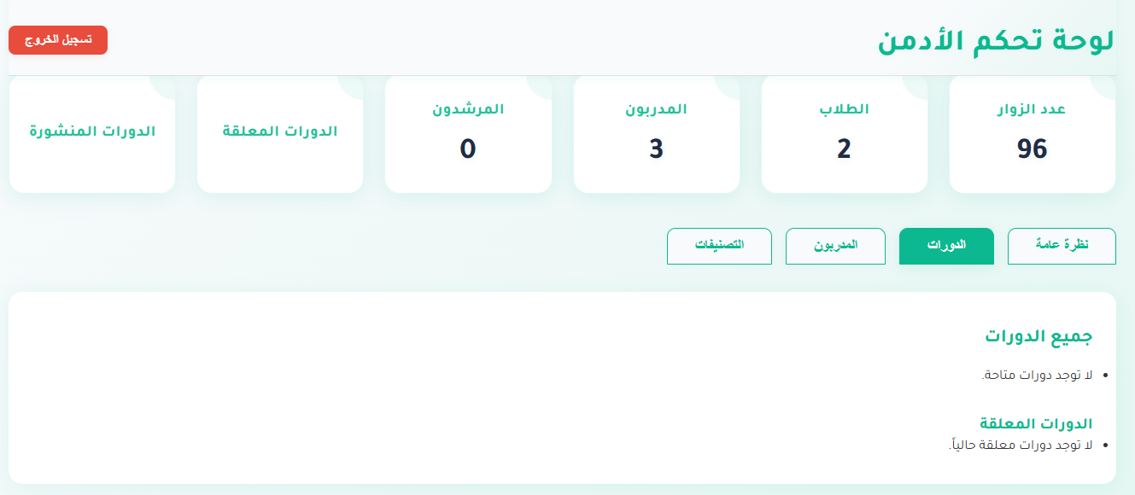

**Admin Dashboard Continue**

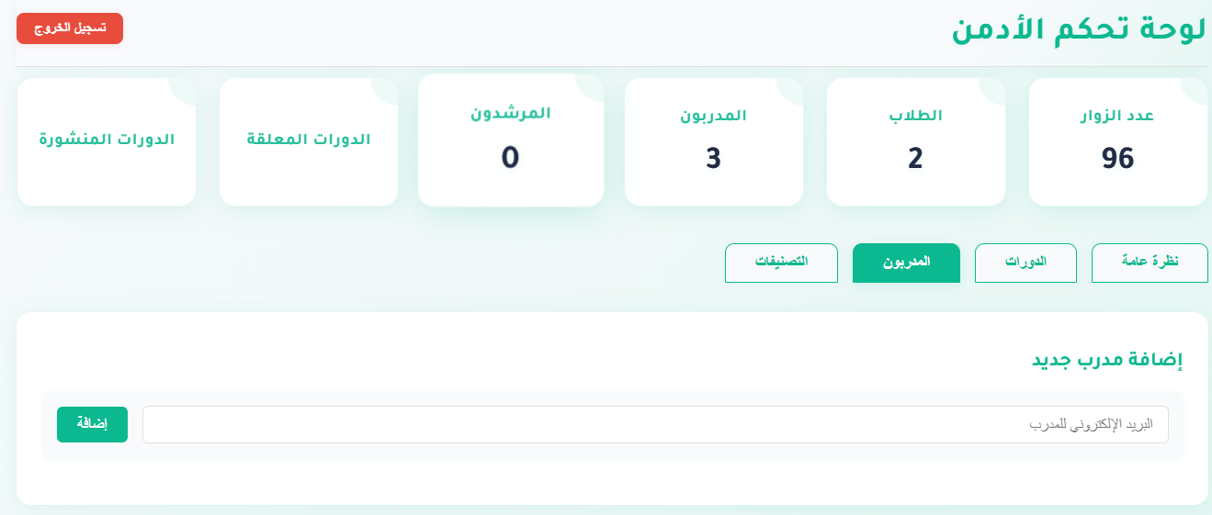

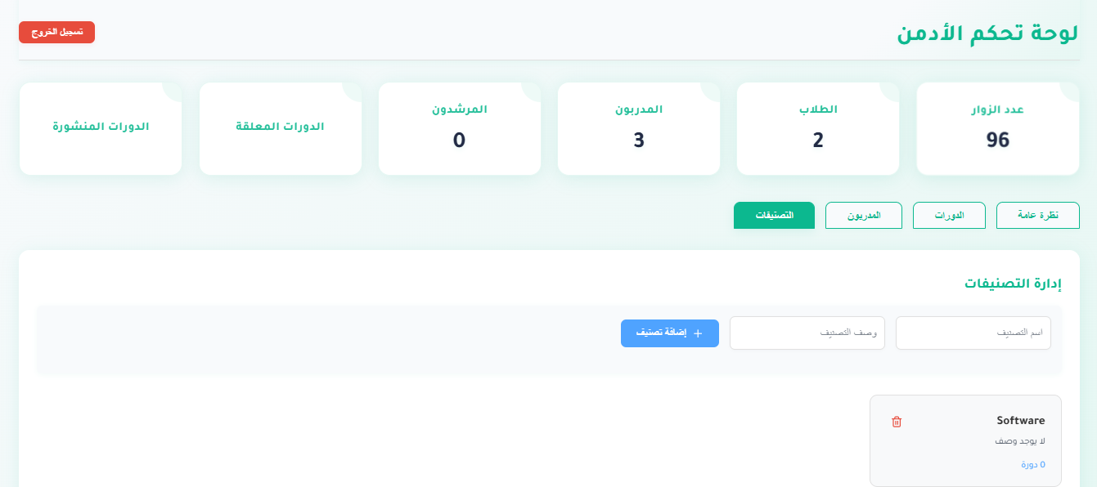

# Chapter 4: Software Requirements Specifications

## 4.1 Overall Description

### Product Perspective

**Makkeny** is a self-contained, user-friendly online platform that simplifies career development for graduates by connecting them with courses, mentors, and companies. It operates as a standalone web application accessible via modern browsers.

### Product Functions

### User Classes and Characteristics

### Operating Environment

### Design and Implementation Constraints

### User Documentation

### Assumptions and Dependencies

## 4.2 External Interface Requirements

### User Interfaces

### Hardware Interfaces

### Software Interfaces

### Communications Interfaces

## 4.3 System Features (Functional Requirements)

### User Management System

### Course and Content Management

### Career Development Services

### Administrative Functions

### Personalized Learning Paths

### Mentoring Management System

### Feedback and Improvement System

## 4.4 Other Nonfunctional Requirements

### Performance Requirements

### Security Requirements

### Software Quality Attributes

### Business Rules

### Culture and political

# Conclusion

The development of the Makkeny web application represents a significant step toward addressing the challenges faced by recent graduates in navigating the labor market. By providing a user-friendly platform that integrates targeted course recommendations, personalized career counseling, mentorship opportunities, and practical training experiences, Makkeny empowers users to enhance their skills and secure meaningful career paths.

The system's design, leveraging technologies such as HTML, CSS, JavaScript, React, and MongoDB, ensures scalability, security, and an intuitive interface supporting both dark and light modes for user convenience.

The successful implementation of key features—such as user registration, course filtering, enrollment management, and admin oversight—demonstrates the project's potential to meet its objectives.

Through rigorous planning, iterative development, and user-centered design, Makkeny not only fulfills its current goals but also lays a solid foundation for future enhancements, promising a positive impact on the professional development of its target audience.

# Future Works

The Makkeny project is poised for continued evolution to maximize its impact and usability. Future enhancements include:

* **AI-Powered Recommendations**: Integrating artificial intelligence to provide personalized course and mentorship suggestions based on user profiles and market trends.
* **Mobile Application Development**: Creating dedicated iOS and Android applications to offer a more portable and optimized user experience, complementing the existing web platform.
* **Advanced Analytics**: Implementing detailed analytics dashboards for admins and users to track progress, engagement, and performance metrics over time.
* **Integration with Job Portals**: Establishing partnerships with job platforms to directly connect graduates with employment opportunities based on their acquired skills. These initiatives aim to position Makkeny as a comprehensive, worldwide tool for career development, ensuring adaptability to emerging needs and technological advancements.
* **Advanced AI or Deep-Learning Models**: Introducing advanced AI or deep-learning models to revolutionize the learning experience on Makkeny. These models will enable predictive analytics for career paths, automated skill assessment, and intelligent tutoring systems that adapt to individual learning paces.
* **Full Accreditation or Certification for Courses**: Pursuing full accreditation or certification for the courses offered on Makkeny, in collaboration with recognized educational institutions or professional bodies. This will enhance the credibility of the training programs, attract more users, and improve employability.
* **CV Management Feature:** A dedicated CV section will be integrated into learners’ profiles, enabling them to create, track, and update their resumes with newly acquired skills and knowledge.

# Appendices

## Appendix A: Professional Considerations

Implementing a professional web application like Makkeny requires meticulous planning and consideration of various factors to ensure success, meet user needs, and operate reliably. Here are the key professional considerations:

**Project Planning and Management**

* **Requirements Gathering**: Conduct thorough analysis to document user needs (e.g., graduates, mentors, admins), business requirements, and technical specifications as outlined in the SRS.
* **Scope Management**: Define a clear project scope to prevent scope creep, focusing on core features like course enrollment and mentorship scheduling.
* **Timeline and Milestones**: Establish realistic timelines and milestones, such as completing the UI design by April 2025 and full deployment by June 2025.
* **Resource Allocation**: Allocate appropriate human resources (e.g., developers, designers), tools (e.g., React, MongoDB), and budget to support development and maintenance.

**Technical Considerations**

* **Technology Stack**: Utilize a robust stack (HTML, CSS, JavaScript, Node.js, React, MongoDB) suitable for scalability and aligned with project requirements.
* **Scalability and Performance**: Design the system to handle increasing user loads and ensure fast response times, with cloud hosting as a scalable solution.
* **Security**: Implement HTTPS, firewalls, and data encryption to protect user information against threats and vulnerabilities.

**Development Practices**

* **Agile Methodology**: Adopt agile practices for iterative development, allowing regular feedback from stakeholders and users.
* **Version Control**: Use Git for code management to track changes and collaborate effectively among team members.
* **Code Quality**: Maintain high standards through code reviews, automated testing, and adherence to coding guidelines.
* **Documentation**: Provide comprehensive documentation for developers and end-users.

**User Experience (UX)**

* **User-Centered Design**: Design the UI with an intuitive layout and support for dark/light modes, ensuring a positive experience for all user types.
* **Accessibility**: Ensure the Platform is accessible to all users.
* **Usability Testing**: Conduct testing sessions with target users to gather feedback and refine the interface.

**Deployment and Maintenance**

* **Deployment Strategy**: Plan for efficient deployment processes.
* **Monitoring and Logging**: Implement tools to track performance and detect issues in real-time post-launch.
* **Support and Maintenance**: Plan for ongoing support, bug fixes, and updates.

**Communication and Collaboration**

* **Stakeholder Engagement**: Regularly communicate with stakeholders to keep them informed, involved and incorporate their feedback.
* **Team Collaboration**: Foster a collaborative environment among team members.

**Risk Management**

* **Risk Assessment**: Identify potential risks and develop mitigation strategies.
* **Contingency Planning:** Prepare for unforeseen issues with contingency plans.

## Appendix B: Glossary / Acronyms

* **UI (User Interface)**: The visual and interactive elements that users engage with.
* **API**: Application Programming Interface
* **UX**: User Experience
* **CRUD**: Create, Read, Update, Delete
* **NoSQL**: Not Only Structured Query Language
* **ERD (Entity-Relationship Diagram)**: A model showing relationships between entities in the database.
* **UML (Unified Modeling Language)**: A standardized modeling language used to visualize the design and architecture.
* **MongoDB**: A NoSQL database used for storing data.
* **React**: A JavaScript library utilized for building dynamic and responsive user interfaces.
* **Node.js**: A runtime environment built on Chrome’s V8 JavaScript engine, to handle server-side operations, enabling efficient data processing and API development.

## Appendix C: To Be Determined List

* Final decision on mobile app development timeline.
* collaboration with recognized educational institutions to get Full Accreditation or Certification for Courses
* Integration strategy with external job portals.

# References